



**Glasgow’s Public Golf Courses**

**Community Engagement**

Survey Results

**--------------------------------------------------------------**

Carried out by:-

Glasgow Life, Emirates Arena, 1000 London Road, Glasgow. G40 3HG

Telephone 0141 287 8931

**BACKGROUND AND OBJECTIVES**

At present Glasgow has six public golf courses which are operated on behalf of the City Council by its cultural and sporting charity which is Glasgow Life. There are three 18-hole courses and three 9-hole courses.

Low usage figures combined with a substantial annual deficit incurred in the provision of these facilities required us to seek views and suggestions from all interested parties – both golfers - non-golfers – and local communities - as what best to do to address these challenges.

We asked for their suggestions and ideas and also what other use or purpose the courses might have if retaining them all for golf was no longer possible.

The survey ran for 6 weeks in Summer 2019

**Summary Response Rate**

* A variety of methods were used to direct people to the survey hosted in Smart Survey (www.smartsurvey.co.uk/s/GolfConsultation/). This included a direct email to 31,832 Glasgow Club members, Glasgow City Council Councillors, Glasgow Life Golf users and clubs, Glasgow Golf Union (clubs and members) and several social media posts. It was also published on the Glasgow City Council Consultation site and publicised in the media.
* The survey was completed by 2,071 respondents.

**Survey Methods**

The survey was designed and hosted in Smart Survey using the link www.smartsurvey.co.uk/s/GolfConsultation/. A variety of methods were used to direct the pubic to the survey:-

**Direct Email**

An email invitation was sent to all Glasgow Club members (with a valid email address and who had opted into correspondence), Glasgow Life Golf users and clubs, and to the Glasgow Golf Union (clubs and members).

**Social media**

There were organic posts across Glasgow Sport and Glasgow Club Twitter and Facebook profiles.

**Glasgow City Council Elected Members**

An email was sent to all Elected Members via the Chief Executive’s Department.

**Glasgow City Council Consultation**

There was a post added to Glasgow City Councils Consultation site with a direct link to the survey.

**Press Coverage**

The survey received coverage from several media outlets including the fact that there was a two week extension due to the amount of interest in the consultation. This included:-

* Evening Times
* Glasgow Live
* The Herald
* Rutherglen Reformer

**Key findings**

* Respondents would like Glasgow’s public courses to remain open.

When asked to consider the future of Glasgow City Council public courses and how this would be achieved, given the current financial pressures, over a third (37.5%, n=777) of respondents selected “Have seasonal opening hours only (April to October) to save money”, followed by “Substantially reduce the price to play to ensure much more use” (30.35%, n=628)

* The current price, across adult and junior, provision was overwhelmingly considered excellent or very good in terms of value for money. When respondents were asked to select from a matrix of choices describing value for money in adult and junior pricing, “Excellent” came out top in every category. This was reinforced when reasons for playing on courses other than Glasgow’s public courses was reviewed; price was indicated by only 4.8% of respondents.

• The main reason respondents choose an alternative providers is the “quality of the courses” (62.2%) followed by “friends and family play there” (53.7%).

* Of those who responded 50.85% (1053) currently play golf and 76% (806) of those currently play on Glasgow’s public courses.

• Of the respondents who play on Glasgow’s public courses, 68.36% (551) also play on other providers courses, 86% of these are private courses.

* Respondents who don’t currently play golf were asked how interested they were in playing and two thirds were either “not at all interested” (41.86%, 427) or “not interested” (23.73%, 242).

**Full Survey Results**

The following analysis of responses follows the order of the questions which were asked in the survey. Additional analysis is included on an ad hoc basis when it is deemed to broaden understanding of the results. The analysis is based only on the views of only those who responded to the survey.

**Q1. Do you currently play Golf?**

The percentage of respondents that play golf and do not play golf was almost equal, 50.8% (n=1053) indicated yes and 49.2% (n=1018) indicated no.

**[Q2] On average, how often do you play?**

The following question was only asked to those that indicated “yes” to the previous question [**Do you currently play Golf?** (i.e. 1,058)].

The most common anwer was once a week (24.7% n=260), the second most common answer was once or twice a month 24.1% (n=254). The least common answer was more than twice a week 13.7% (n=144).

A majority of respondents 57.4% (604) play once a week or more.

**[Q3] Do you play on Glasgow's public golf courses?**

Respondents were then asked “Do you play on Glasgow's public golf courses?”. Over three quarters 76.5% (n=806) indicated that they did, 22% indicated no and 1.4% were unsure who managed the course.

It is intersting to note that there is little change between usage patterns of respondents who play on a Glasgow public course and those who play on other courses.

Respondents who indicated that they play on a Glasgow public course and that they play once a week was 25.8% (n=208) against a combined average of 24.7% (based on once a week response for both yes and no combined).

The majority of respondents, that play on a Glasgow public course play once a week or more, 56.8% (n=458). Anecdotally, the usage indicated by the respondents across a 32 week year would equate to nearly 35,000 usage. In excess of the total golf usage for 2018/19 which was only 23,207 “paid for” rounds of golf.

**[Q4] How do you pay to play on Glasgow's public golf courses?**

n.b. this question was asked only to those respondents who indicated they play on Glasgow public courses i.e. 806 respondents.

Respondents were then asked “How do you pay to play on Glasgow's public golf courses?”. The vast majoty, nearly 9 out of ten respondents (87.1% (n=703) pay as they play, with 12.9% (n=104) holding a season ticket / membership.

**[Q5] Which of Glasgow's public golf courses do you use? (Please select all that apply)**

The question was then asked which courses do you use. Respondents could chose more than one option so the total responses will be greater than the number of respondents.

The most common answer were Lethamhill, followed by Linn Park and Littlehill. The three 18 hole public courses. The least popular was Ruchill.

For information the respondents preference is ranked below alongside the usage of courses – ranked first to sixth.

|  |  |  |
| --- | --- | --- |
|  | **Respondents** | **Usage** |
| **1st** | Lethamhill | Knightwood |
| **2nd** | Linn Park | Littlehill |
| **3rd** | Littlehill | Linpark |
| **4th** | Knightwood | Lethamhill |
| **5th** | Alexandra Park | Alexandra Park |
| **6th** | Ruchill | Ruchill |

Respondents were then asked a series of questions on their perception of the value for money of junior and adult prices across summer and winter.

**[Q6] How would you describe our junior (under 18 year's old) pricing in terms of value for money? i.e. 9 hole courses in winter £2.00**

Respondents who play of Glasgow public courses i.e. 806 were then asked “How would you describe our junior (under 18 year's old) pricing in terms of value for money?**”.**

The majority, of respondented, 58.7% (n=473) indicated that the price was excellent. With 92.4% (n=745) indicating between Excellent and fair. Only 2.5% (n=20) indicated it was poor and 1.4% (n=11) indicating it was very poor. 3.7% (n=30) had no comment or were uunsure.

**[Q6] How would you describe our Junior (under 18 year's old) pricing in terms of value for money? i.e. 9 hole courses in summer £3.50**

A similar picture emerges for nine hole courses in summer with the majority of respondents indicated the price is excellent, 56.0% (n=451). With 90.8% (n=732 indicating the price is somewhere between excllent and fair. Again a small percetage 5.7% (n=46) indicated the the price either poor (4.1% (n=33) or very poor (1.6% (n=13)).

Akin to the above question 3,5% (n=28) had no comment / unsure.

**[Q6] How would you describe our junior (under 18 year's old) pricing in terms of value for money? 18 hole courses in winter £3.50**

Simialar to the nine hole courses above respondents indicated strongly the value for money of the current price. Nine out of ten people indicated between excellent and fair .

**[Q6] How would you describe our junior (under 18 year's old) pricing in terms of value for money? 18 hole courses in summer £6.00**

There was small adverse movement in the number of respondenst that indicated the strongest value for money option, droped below 50% with 47.4% indicating excellent. Overwhelming (86.5% n=697) of respondents still indicated the current price was value for money.

10.2% (n=82) indicated they felt value for money was either poor (n=66) or very poor (n=16).

A consistent 3.5% (n=27) indicated no comment / unsure.

**[Q7] How would you describe our Adult (18 years and over) pricing in terms of value for money? 9 holes course in winter £4.50**

The most common response (42.9% n=346) indicated that the price was excellent. With the majority 89.3% (720) indicating the price was somewhere between ecellent and fair.

Poor was selected by 6.5% (n=52) respondents and very poor was selcted by 2.9% (n=23). The option no comment / unsure was selected by 1.4% (n=11).

**[Q7] How would you describe our Adult (18 years and over) pricing in terms of value for money? 9 holes course in summer £7.50**

The majority of people indicated the price was excellent, 35.2% (n=284). A further 25.3 (n=204) indicated the price was good and 22.0% (n=177) stated it was fair. Overall 82.5% (n=665) indicated the prce was between excellent and fair.

12.8% (n=103) of respondents indicated the value for money was poor with 3.3% (n=27) indicating very poor.

1.4% (n=11) respondents had no comment / ensure.

**[Q7] How would you describe our Adult (18 years and over) pricing in terms of value for money? 18 holes course in winter £7.50**

In terms of value for money for adults, 18 hole golf course during the winter, the majority 38.7% (n=312) indicated it was excellent value for money. The second most popular was good ,24.4% (n=197) and fair 22.2% (n=179).

The option poor was selected by 10.4% (n=84) and very poor by 3.3% (n=27). Only 0.9% (n=7) had no comment / unsure.

**[Q7] How would you describe our Adult (18 years and over) pricing in terms of value for money? 18 holes course in summer £12.00**

The value for money for an 18 holes course in summer is indicated as excellent by the majority of respondents, 31% (n=250). Fair is indicated as the second most common response with 23.7% (n=191). The third most common response is good with 22.2% (n=179).

The responses to the value for money question during summer was the least positive in terms of value for money but despite still over three quarters (76.9% (n=620) indicated it was value for money was between excellent and fair.

Nearly a quarter of responses 22.1% (n178) indicated they felt value for money was either poor (n=135) or very poor (n=43). The option no comment / unsure was chosen by 1.0% (n=8).

**[Q8] Do you play on other golf course? (I.e. other than Glasgow's public golf courses)**

The respondents were then asked if they play golf on other golf courses i.e. other than Glasgow’s public golf courses. Over two thirds of respondents, 68.4% (n=551) play golf on a course in addition to a Glasgow public course. The minority 31.6% (n=255) only play on a Glasgow public course.

n.b. the question was only asked to the 806 that indicated they play on Glasgow’s public courses.

**[Q9] Which courses do you play on? (select any that apply)**

Respondents were then asked which courses do you play on? Respondents were asked to slect all options that apply therefore the numbers add up to more than 806.

The majority 68.1% (n=691) of respondents also play on a private course and 24.7% (n=250) play on another local authority course (excluding Glasgow).

The option other was chosen by 7.2% (n=73). The full list of answers are listed below (please note that comments are exactly as completed by the respondent and that no editing has been done.)

|  |
| --- |
| I plan to paly at Stirling University when i undertake an MSC ful time in September 2019. |
|  |
| South Lanarkshire Some around Scotland |
| Dalmuir Golf Course (West Dunbartonshire) |
| Westerwood - mount ellen - Drumpellier snd calderbraes |
| Mearns castle golf course Airdrie golf course |
| Airdrie |
| other courses around the country which may or may not be public courses |
| Dalmuir, Alexandria |
| I primarily play on the Queens Park pitch and putt course on the southside of Glasgow.  I was devastated to find that this course is no longer being offered as a service as part of Glasgow Life. I've played on that course for over 10 years. To solely offer 9 hole and 18 whole courses I believe is a huge mistake. For children just starting out in golf, I always felt the Queens park pitch and putt was a perfect introduction to the game. Without the pressure to play well from other more experienced users and shorter distances to cover, juniors and amateurs could find a love for the game before heading to more advanced courses.  I feel it doesn't take much to maintain and continue to offer this service. It simply requires the grass trimmed for the few months it can be used each summer, and someone to put out the flags. That's it. As a taxpayer I feel let down by the decision not to offer this service anymore for how little it would cost. Perhaps charging a small fee to rent the equipment could be a solution. But to do away with it altogether is a real tragedy. Again, this is only used primarily for half of the year during the few summer we have in Glasgow. Even if the grass could continue to be maintained, and the greens cut shorter, this could still be used for those with access to their own equipment, rather than it falling into a state of disrepair.  I think this is a real loss to the community and to the development of young players in one of Scotland's chief sporting exports.  I hope you consider these concerns. |
| Hayston |
| I use tee times website |
| I have recently started playing when visiting family in South Africa. |
| Sandyhills golf club |
| Non i have an ailment with my back at present not played for 18 months.. |
| palacerigg kirkwood |
| Sandyhills however the Glasgow club courses are good for beginners |
| Mostly abroad i.e. Spain/Canary Isles. |
| Roukenglen |
| Crowwood ,cathcart castle |
| Pitch and putt at bellahouston park |
| I have played Knighstwood in the past. |
| Lethamhill |
| Member at heritage links East Kilbride |
| Private course outside Glasgow |
| Mearns golf academy & Play sport east Kilbride & Deconsbank golf course |
| Balmore, Windyhill |
| Wee demon loch lomond |
| Sandyhills |
|  |
| i am answering this on behalf of my husband who is a keen and frequent golfer. I have heard of him playing on some of the Glasgow courses but he has also played on various other ones. he plays more often in the summer months / light nights than he does in the winter months |
| Previously played on Glasgow's courses. Now live in neighbouring authority and use local course. |
| Not sure which courses are public.  Also noticed Queen's Park Pitch and Put does not seem to be up and running? |
| Occasionally Ayrshire.  Not the Glasgow courses as the condition of them is terrible. |
| Crow wood |
| abroad on holiday |
| I am a member of cambuslang golf club. |
| Opens via golfempire and hot deals on private courses through teeofftimes |
| clober gc |
| Holiday Courses abroad |
| Troon, Dalmuir |
| Torrance, east kilbride Langlands,east kilbride |
| I'm a golfer, though not had much opportunity to play lately. |
| Braehead Golf Club... |
| Various open competitions |
| Courses when on holiday in Scotland, so a mixture of different local authority courses and private courses |
| Rouken Glen |
| Torrance House and Dalmuir |
| Troon Links run by South Ayrshire Council |
| Nuffield Health (Dougalstoun) |
| Hamilton 9 hole |
| I tend to look for deals that offer well conditioned courses at reasonable prices |
| Westerwood |
| Castle Park  Sandy hills Polkemmett Barshaw Newbattle  Drumpellier |
| Ross Priory, University of Strathclyde( 9 hole course by Gartocharn) |
| Rouken glen course |
| Cawder |
| Rouken Glen |
| Occasional golfer |
| Caldwell |
| Lethamhill..Linn Park |
| Hollandbush gc |
| Auchterarder as a guest |
| Lethamhill |
| Sandyhills |
| Just started lessons, hoping to play Alexandra Park! |
| Abroad |
| Dalmuir |
| World of golf driving range |
| North Lanarkshire lochside, Drumpellier, corses on GreenFree |
| Play sport east kilbride |
| Dalmuir Troon links (3 courses) |
| Various on Isle of Arran |
|  |

**[Q11] Why do you choose these courses rather than Glasgow's public golf courses? (Please select all that apply)**

Respondents were then asked to chose from a predefined list of reasons why they choose these courses rather than Glasgow's public golf courses? The option “other” was also provided with a free text box.

n.b. respondents could chose more than one option therefore the numbers will add up to more than 806.

The two main reason respondesnts chose to use other courses was quality of the course, 24.3% (n=497) and friends / familiy play there, 20.7% (n=424). The third most common reason was club house facilities, 13.1% (n=269).

The reason least cited was transport links, 1.1% (n=22) and social programme 3.0% (n=61). Price was the fourth least cited option, selected 4.8% (n=99).

The option other was selected by 4.8% (n=98), a full list of the responses are shown below.

|  |
| --- |
| Q11.10. Other (please specify): |
|  |
| Where I study |
| Driving range. No dog walking through course. Overall condition. For the same price |
| Not sure what courses Glasgow life operate or fact that they did provide this facility |
| Security..too many drunks on your courses |
| Just to play on a different course |
| member of one of them |
| didn't know there were glasgow life courses |
| Holiday home In Rothesay |
| The Glasgow courses are in terrible condition |
| More winter weather-proof at coast. |
| friends are members |
| Driving range |
| Place of work |
| Variation |
| I enjoy the membership of a club. |
| Not rather but in addition to - poor question |
| non ill health |
| When on holiday |
| Via work |
| Driving range available |
| Charity days |
| only use when on holiday |
| I work there so it’s free |
| I didn’t know Glasgow had public courses. As a resident of Glasgow and active member of Glasgow Club, I’m now very interested in using them! |
| N/a |
| A change |
| For a wee change / day out. |
| Safety |
| youth programme |
| spur of the moment decision |
| Closer proximity to home |
| Also not sure where public courses are |
| special deals |
| The clubhouse’s at the venues are far better than the absolute hell holes that Glasgow life have the cheek to call a clubhouse, they need major redevelopment to make profitable. |
| For the fact the greens are in much better condition than lin parks |
| clober has a reciprocal golf arraangement with local private clubs for golf at reduced green fees/be good if littlehill and lethamhill were included |
| The scenery and unique locations. Also as part of a weekend away. |
| maintenance of course |
| I wasn't aware I had a course so close to me |
| Feel safer playing them than Knightswood. |
| I’m member at private club |
| Member |
| Didn’t know about the Glasgow courses |
| Just cause I do |
| Feel more secure on a private course |
| It’s also easier to pay. Last time I was at a Glasgow public course there was no facility to pay by card. |
| For something different |
| Nearest when staying in Glasgow |
| Working away from home |
| Membership of one of the courses |
| I play vairious courses to challenge my game |
| Variety. I don’t like playing the same course all the time. |
| Like to try different courses |
| I live in Stirling... |
| Variety of landscape |
| Convenient location between players that is fairly priced for a good condition course |
| Golf shop |
| To change it up |
| Friends sign me on as free guest |
| Outing with friends |
| good memories from younger |
| Best deals on Teeofftimes app. Can usually get better standard of course for similar price to council courses. |
| It's not either or I play various courses |
| Just for a change but the public 18 hole courses are just as good sometimes better especially lethamhill great course |
| We're close to where I worked before retiring like to play with old colleagues |
| Weather can be better at coast |
| Safety, do not feel safe on my own on council courses |
| Work purposes |
| When on holiday |
| Time after time, the public courses are full of yobs who have no respect for the course or it’s golfers. Motorbikes on the greens tearing up the grass is just one element that is absolutely scandalous. Furthermore, flags are often missing and this majorly takes the shine off the course - making it incredibly difficult to play. It is very frustrating paying the ridiculous price and then finding there are no flags in any of the holes. I understand this is out-with the control of the council, however there are measures that should be put in place. Perhaps a telephone number to call or an app where reports can be filed. |
| Golf in scotland events |
| weather |
| Feels Safe, Club Rules, Other Respectful Used |
| I did not know of Glasgow council golf courses |
| Just for a change sometimes |
| Long term member |
| fancy a change |
| Played there for long time |
| Holiday accommodation. |
| Through wirk |
| Don't play private courses too pricey |
| I play as a guest 4 times a year |
| Caravan at Maidens |
| Central for group of friends |
| Less hassle |
| Friends that live out with Glasgow live close by. I play here only on a rare occasion. |
| Social |
| Na |
| Member |
| As not a member of any other club tend play on different t courses |
| The condition of the course greens |
| just like a change rather than same one all the time |
| Littlehill is where I learned to play and always play there every chance I get. My local course to parents which has lots of happy memories. |
| No dog mess |
| Driving facilities |
| Driving range and similar prices for off peak golf |
| Variety |
| when im on holiday |

**[Q12] Did you play more or less often in 2018/19 than you did in previous years?**

Respondents were then asked if they played more or less often in 2018/19 than they did in previous years? The majority 50.7% (n=534) play about the same, with 31.4% (n=331) indicating they played more often and the monirity 17.9% (188) indicating they played less often. Those that indicated they played less often (17.1%) were then asked Question 13 – Why are you currently playing less often than in the previous year?

**[Q13] Why are you currently playing less often than in the previous year?**

The question was constructed to allow more than one option per respondent.

The most common answer was work commitments 22.3% (n=69), and have less time 22.3% (n=69) followed by family / children responsibities (18.1% n=56). Taken together the “lack of free time” accounts for 62.7% (n=194) of all responses (respondants could select more than one option).

The least common response was courses are too crowded, indicated by 1.0% (n=3).

The option other was slected by 7.1% (n=22), the full list of responses is shown below. It is worth noting the majority of responses relate to a factor outwith our control - Scottish weather.

|  |
| --- |
|  |
| Q13.9. Other (please specify): |
|  |
| Pitch and Putt has been closed |
| Weather |
| Bloody weather. |
| Weather |
| Injury |
| Weather |
| major renovations to home |
| Lack of on course maintenance |
| Golfers play too slowly, 18 holes can be completed in 3 hours or less. |
| Injured plus gave up membership at private course due to cost |
| bad weather |
| Weather |
| Littlehill greens poor last 5years poor workmanship on greens |
| Public courses are not as well looked after |
| Family commitments |
| Courses can be isolated with groups of teenagers roaming about |
| Weather |
| Loss of hours in job, can't afford it as much |
| Family illness and Bereavement |
| Weather related |
| Just started learning this year |
| weather |
|  |

**[Q14] How interested are you in playing golf?**

Those respondents that answered no to the first question [Q1]”Do you currently play golf?” i.e. 1018 were moved to [Q14] “How interested are you in playing golf?”

The most common response was not interested at all (41.9% n=427). The second most common response was moderately interested with 25.7% (n=262).

The majority 65.7% (n=669) were either not interested at all (41.9% n=427) or not very interested 23.8% (n=242).

Extremely interested recorded the fewest responses 1.9%, (n=19). The second lowest response was very interested with 6.7% (n=68).

Respondents were then presented with a matrix of possible options and asked to rank them from first (prefered option) to sixth (least prefered option).

**[Q15] What would encourage you to play on Glasgow's public golf courses?**

Respondents who indicated that they don’t play golf, and that they were moderately, very or extremely interested in playing, were asked this free text question.

The most common response related to lessons with a large number also suggesting equipment hire and lower pricing. It was very evident amongst these respondents that there is a lack of awareness of public courses and the facilities they offer. Better marketing, signage and promotions could help encourage many of these non-user.

**[Q16] What suggestions do you have for increasing participation on Glasgow's public golf courses?**

All respondents were asked this free text question.

Responses to this question were very similar to those in question 15, with lessons, equipment hire, lower pricing and greater awareness of courses being amongst the most common responses. In addition, better facilities and an improvement in the condition and quality of courses were common suggestion for increasing participation.

**[Q17] Bearing in mind the present substantial annual deficit being incurred, which of the options below do you think should be considered for the future of Glasgow’s public golf courses? (Please rank these in order with 1st being your preferred option).**

The matrix of answers is shown below.

n.b. this question was asked to all survey respondents, irrespective of if and where they play golf.

|  |  |  |  |  |  |  |
| --- | --- | --- | --- | --- | --- | --- |
|  | 1st | 2nd | 3rd | 4th | 5th | 6th |
| Have seasonal opening hours only (April to October) to save money | 37.5% | 28.0% | 18.4% | 9.2% | 4.1% | 2.8% |
| 777 | 580 | 382 | 190 | 84 | 58 |
| Have revised/restricted opening hours to save money | 11.5% | 39.5% | 29.2% | 11.7% | 6.9% | 1.2% |
| 238 | 818 | 605 | 243 | 142 | 25 |
| Substantially reduce the price to play to ensure much more use | 30.3% | 14.5% | 29.4% | 14.1% | 6.3% | 5.5% |
| 628 | 300 | 608 | 292 | 130 | 113 |
| Substantially increase the price to play to reduce the annual deficit | 2.5% | 3.6% | 11.6% | 37.2% | 31.9% | 13.1% |
| 52 | 75 | 241 | 771 | 660 | 272 |
| Reduce the number of public golf courses to limit the deficit | 13.5% | 10.8% | 8.9% | 23.5% | 40.6% | 2.8% |
| 279 | 223 | 184 | 486 | 841 | 58 |
| No longer have any public golf facilities and leave to the private courses to meet the demand | 4.7% | 3.6% | 2.5% | 4.3% | 10.3% | 74.6% |
| 97 | 75 | 51 | 89 | 214 | 1545 |

The results of this queston are as follow:

1. Have seasonal opening hours only (April to October) to save money
2. Have revised/restricted opening hours to save money
3. Substantially reduce the price to play to ensure much more use
4. Substantially increase the price to play to reduce the annual deficit
5. Reduce the number of public golf courses to limit the deficit
6. No longer have any public golf facilities and leave to the private courses to meet the demand

The option ranked first most often was “have seasonal opening hours only (April to October) to save money” 37.5% (n=777) respondents. The option to “substantially reduce the price to play to ensure much more use” was chosen as first option by a significant proportion of repsondents, 30.3% (n=628).

The option to “have revised/restricted opening hours to save money” was ranked second by 39.5% (n=818) of respondents.

The option to “Substantially reduce the price to play to ensure much more use” was the ranked third by 29.4% (n=608). It is worth noting this option was selected first by a larger proportion of respondents than chose it as there third option.

A table for each option is provided below.

It is worth noting this option was ranked first among those that currently play and those that do not currently play, per below.

**[Q17] Have revised/restricted opening hours to save money**

This option was ranked second amoungst those that currently play and those that do not currently play, per below, however there is a more notable gap.

**[Q17] Substantially reduce the price to play to ensure much more use**

The option to “Substantially reduce the price to play to ensure much more use” was first choice of 30.3% (n=628). Overall, “ have seasonal opening hours only (April to October) to save money” had the most 1st options with (n=777). More people had it as a first choice than a third choice.

It was second choice of 14.5% (n=300) and third choice of 29.4% (n=608).

The diference of betweeen those that play golf “yes” and those that do not “no” is shown below.

**[Q17] Substantially increase the price to play to reduce the annual deficit**

The option to “substantially increase the price to play to reduce the annual deficit” was the most common fourth choice option with 37.2% (n=771). It was also high on respondents fifth choice. It was only first choice for 2.5% (n=40) of respondents. Similarly is was not a popular second choice with only 3.6% (n=30) of respondents incdicating it as their second choice. As with previous questions there was small difference between the responses of those that indicated they played golf and those that indicated they did not.

**[Q17] Reduce the number of public golf courses to limit the deficit**

The option to “reduce the number of public golf courses to limit the deficit” was ranked fifth the most times with 40.6% (n=841). When the option to reduce the number of public golf courses was split per those that play and those that do not play a small divergence is evident.

The second most common rank for the closure option was fourth with 23.5% (n=486). The third most common rank for this option was first with 13.5% (n=279).

**[Q17] No longer have any public golf facilities and leave to the private courses to meet the demand**

The final option was “no longer have any public golf facilities and leave to the private courses to meet the demand”. This option was ranked sixth by nearly three quarters of the respondents, 74.6% (n=1545).

The option to close all courses was ranked fifth by 10.3% (n=214) of respondents. A combibed total of 10.3% (223) ranked this option between first and third.

Perhaps unsurprisingly there was a stronger feeling against “no longer have any public golf facilities and leave it to the private courses to meet the demand” from those that currently play golf, as a greater percetange ranked in sixth and those that did not play. Similarly those that indicated this option as their first preference was notibly higher amoungst those that do not play golf.

**[Q18]** **What should happen to a public course is it had to close?**

A free text box was used for this question. Reponses are displayed below in a word cloud to highlight the most used words:-

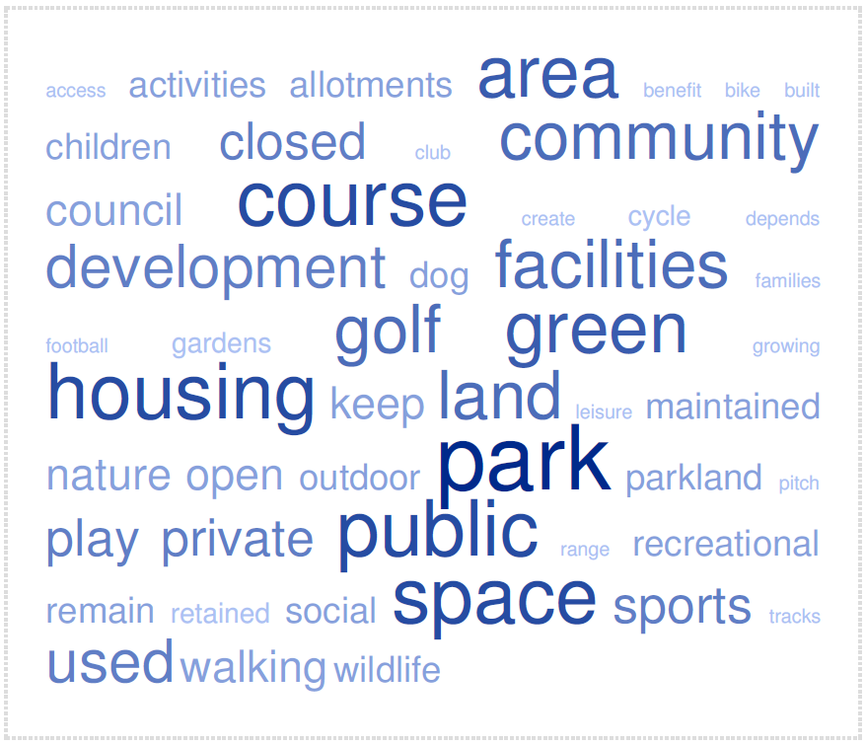

There was a wide variety of suggestions provided, however, respondents would like to retain the courses as outdoor, green space. There was some commonality in the suggested usage with a significant number pointing towards community, family friendly parks which focus on outdoor activity, environmental education and green initiatives. Dog walking areas, biking routes and nature trails were also popular requests.

Where housing was suggested this was heavily focused towards social, affordable housing.

**[Q19] Please tell us about any other ideas, comments or suggestions you wish to share?**

Again, a free text box was used for this question. Reponses are displayed below in a word cloud to highlight the most used words:-

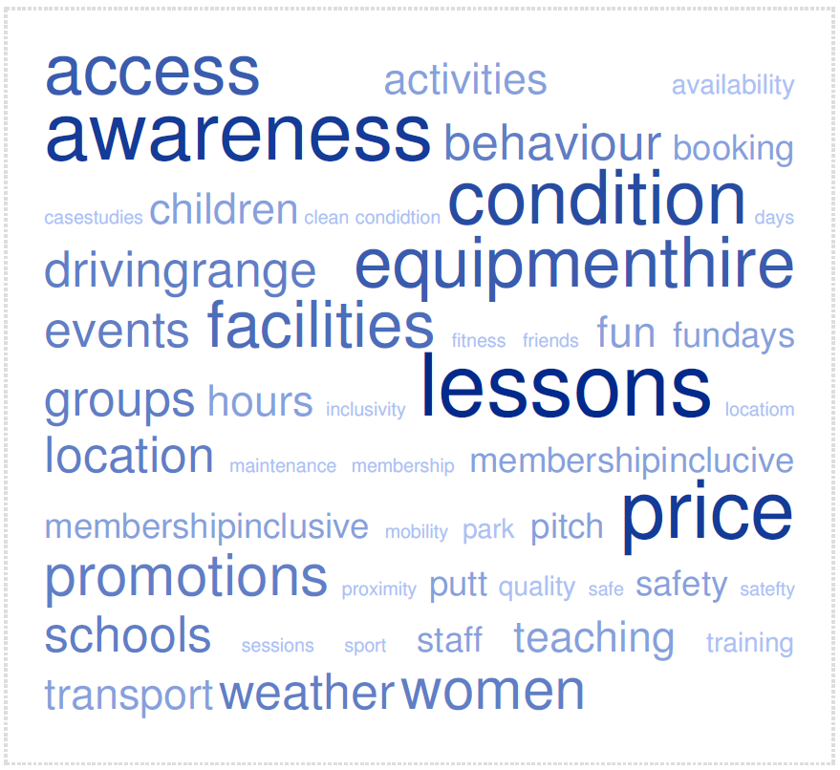

Again, It was clear that there is a lack of awareness of public courses with better marketing and promotions being suggested by a large number of respondants. Working closer with schools and community groups and offering ladies only sessions were also common suggestions

Many of the responses to this question reflected the responses given in Question 18 by non golfers, such as offering lessons, equipmment hire and greater awareness.

As with Question 16, better facilities and an improvement in the condition and quality of courses were also common suggestions.

The remaining questions concern customer deomgraphics.

**[Q20] Please provide your postcode**

The following chart shows responses by Glasgow ward area. The largest number of respondents came from Dennistoun with 10% (n=158) of responses. The lowest was Anderston/City/Yorkhill with 1% (n=14)

A total of 281 responses came from out -with the Glasgow City Council Area. The local authority area is shown below.

|  |  |  |
| --- | --- | --- |
| Local Authority Name | Count | % |
| Glasgow City | 1,571 | 84.8% |
| Argyll and Bute | 1 | 0.1% |
| East Ayrshire | 2 | 0.1% |
| East Dunbartonshire | 81 | 4.4% |
| East Renfrewshire | 46 | 2.5% |
| Falkirk | 1 | 0.1% |
| North Lanarkshire | 23 | 1.2% |
| Renfrewshire | 17 | 0.9% |
| South Lanarkshire | 86 | 4.6% |
| Stirling | 4 | 0.2% |
| West Dunbartonshire | 20 | 1.1% |
|  | 1,852 | 100.0% |

Please note 150 postcodes were incomplete or unidentifiable

**[Q21] What age range applied to you on your last birthday?**

The majority of respondents were aged 45-54 (23.7% n=490) followed by 35-44 (22.0% n=456) and 25-34 (19.3% n=400). The sixty plus age group was fourth with 16.7% (n=346).

**[Q22] Are you:-**

Nearly two third of respondents were male 60.9% (n=1262) against 35.3% (n=732) female. 3.7% (n=77) opted not to say.

Surprisingly if the data is segmented into those that answered yes to the first question Q1. Do you currently play golf? The gender gap significantly increases from 60.9% males to 85.2% (n=897) and 35.3% females to 12.0% (n=126).

A significant number of non-playing females, 59.5% (n=606) completed the survey than non-playing males (35.9% n=365).

**[Q23] How would you consider yourself?**

The majority of respondents considrered themselves non disabled.

**[Q24] What is your ethnic group?**

The majority of respondents, 89.7% (n=1,858) were White Scottish, British, Irish. The second most common option was prefer not to say with 5.4% (n=112) of respondents selcteing this option.

**Conclusions**

The survey was completed by 50% players and 50% non- players

Respondents would like Glasgow’s public courses to remain open

When asked to rank how this should be achieved, given the current financial pressures, “Have seasonal opening hours only (April to October) to save money” was ranked first.

The current price, across adult and junior, provision was overwhelmingly considered excellent or very good in terms of value for money. This was reinforced when reasons for playing on courses other than Glasgow’s public courses was reviewed; price was indicated by only 4.8% of respondents.

The main reason respondents use a private provider rather than a public course is “quality of course”

The reason respondents play golf less can be broadly categorised as “lack of free time”.

Amongst those that do not play golf, lack of awareness of Glasgow’s public golf courses was frequently cited.

The provision of lessons was a main driver that would encourage uptake from non-players

There is a disparity between recorded golf usage in Glasgow public courses and respondent’s perceived usage of Glasgow’s public courses**.**

**Survey design comments**

Several comments were received about the survey design itself, as detailed below.

“The consultation seems to be a bit of a muddle, difficult to use and no posters or any advice regarding the closures, also all had to be carried out on computers and lot of people don't have the use of these”

“Out of interest how were the questions designed, I few folk feel it's quite hard to properly submit a view where some questions are pretty restricted”

“Quite a few people in the area have raised IT issues with the golf course consultation, they say the form keeps breaking and doesn't let them submit a response and sometime when they move to the next question it wipes the answers from the previous one”.

“I have just tried, for the third time in as many weeks to complete your golf course survey. On the two previous occasions it failed to send, this time I ran out of dots so could not get to the next page”.

“I've tried for the last couple of weeks to fill in the survey on the golf consultation but this continually crashes and doesn't allow the survey be completed. Waken up and give us golfers a chance to put our views across”

“Three Labour councillors on Glasgow City Council have told me they have had concerns raised with them over the golf course consultation. They say it is "fundamentally flawed". Issues raised include no hard copies of the consultation survey are available so some constituents can't take part, the online form freezing half way through on smartphones and no notices regarding consultation in Alexandra Park”

I've attempted to complete the survey but its faulty please have it checked it removes boxes I've ticked and won’t proceed to next question.

Smart Survey, the software provider who hosted the survey, confirmed there was no performance issue with the survey itself or any interruption to the service. They suggested the issue seemed to be with a misunderstanding of how to complete question 17 (the question numbers when completing the survey can vary from person to person due to the skip logic). For this question, you can only select each option once, however, from feedback received, respondents were trying to select the same option more than once which results in the previous choice being deleted. This left a small number of respondents with the perception that the survey was flawed or freezing.

**APPENDICES**

Appendix 1 Additional comments received from representatives

Appendix 2 Extract of comments received from individuals