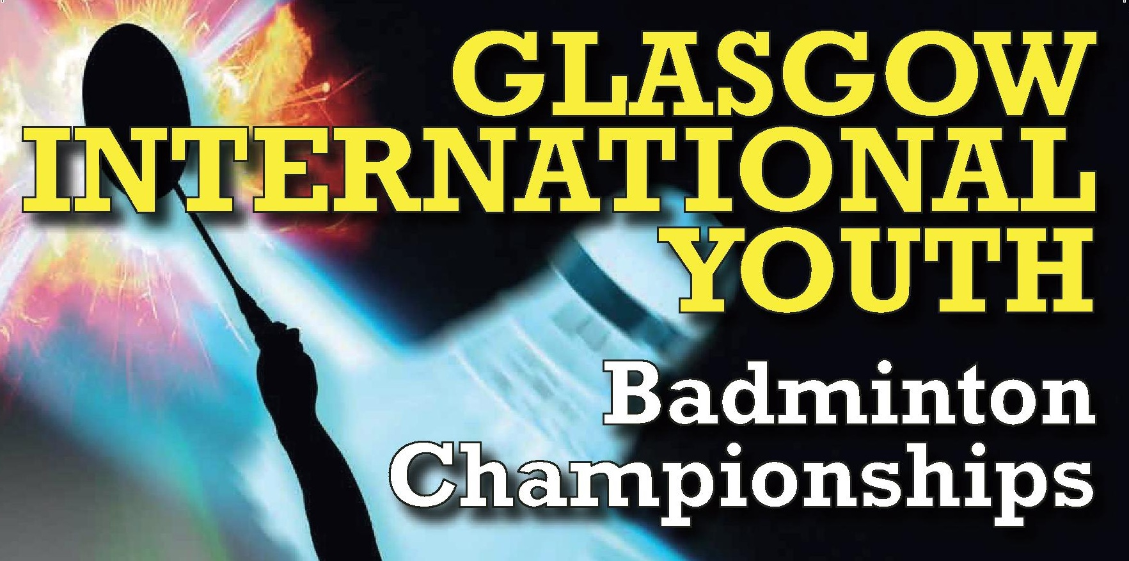
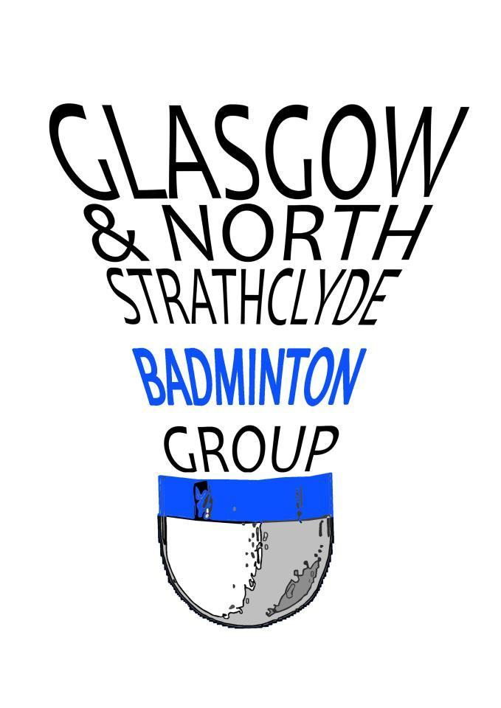

Invitation to:
Glasgow International Youth 2019

Dear Badminton Friends
Glasgow and North Strathclyde Group and Glasgow Sport would like to invite you to the seventh edition of the Glasgow International Youth Badminton Team and Individual Championships 2019. Last year we welcomed players from England, Germany, Hungary, Ireland, Portugal, Poland, USA, Wales and Scotland. Come and join us!

Organisers | Glasgow & North Strathclyde Group (Scotland)  Iain Pringle  Glasgow School of Sport  E: iain.pringle@glasgowlife.org.uk  Telephone: +44 141 287 5971 Mobile: +44 7766 456 936
Sanctioned by | BADMINTONscotland  The tournament will be played in full accordance with the laws of Badminton and Competition Regulations adopted by BADMINTONscotland as well as the regulations of the BWF
Age Groups | Under 13 (Born 2007 or later)  Under 15 (Born 2005 or later)
Eligibility | Scottish players must be affiliated to BADMINTONscotland  Non Scottish players must be affiliated through their National Associations to BWF.
Schedule | Friday 17th May; Team 0900 – 1900  Saturday 18th May; Individual 0900 – 2100  Sunday 19th May; Semi-Finals/Finals 0900 – 1730
Closing Dates |  | Team Entry – 7th April 2019  Individual Entry – 26th April 2019
Venues |  | National Badminton Academy (9 Courts)/Scotstoun Leisure Centre (8 Courts)  Glasgow Club Scotstoun, Danes Drive, Glasgow, G14 9HD  Glasgow School of Sport (6 Courts)  Bellahouston Academy, 30 Gower Terrace, Glasgow, G41 5QE  Sir Craig Reedie Badminton Centre (6 Courts)  12 Bogmoor Place, Glasgow, G51 4TQ

Referee | Mrs Morag McCulloch
Draws |  | Draws will be available 7 days in advance of the competition
Entries |  | Online entry for Individual event:  https://www.tournamentsoftware.com/sport/tournament.aspx?id=BCCAAAED-BF8E-4A77-8DCF-48F327DE53D5  Team entry forms sent to iain.pringle@glasgowlife.org.uk  Individual entry forms can also be sent to:  Iain Pringle  Glasgow School of Sport  Bellahouston Academy, 30 Gower Terrace, Glasgow, G41 5QE
Individual |  | Players can participate in 3 categories. Singles and doubles will be played in pools. Mixed Doubles will be played using the cup system.
Team Package |  | Arrival Thursday 16th May / Departure Sunday 19th May  3 nights accommodation at Hotel (Bed and Breakfast)  Team and Individual entry (Max 3 events in Individual)  Packed Lunch during Team Event only  Transport between official hotel and competition hall  Transport to and from Glasgow Airport / Train Station  Each full team will receive a free package for their coach/leader | £165  Per player
 |  | As above with transport from Edinburgh Airport | £175  Per player
Team Entry Only |  | For teams not using the Package above:  Minimum 6 and maximum 8 players (3 – 4 boys/3 – 4 girls) 1 Coach  Entry to Team Event, packed lunch on Friday and players Youth T-shirt | £25  Per player
Meals |  | Dinner will be available on Friday 17th and Saturday 18th May.  Please use the Meals Form to confirm your order. | £10 per person
Finance  Payments GBP (£) |  | Glasgow and North Strathclyde Group  Bank: Bank of Scotland  Bank Account No: 00391761 Sort Code: 80-09-22  IBAN No.: BOFSGB21091  BIC/SWIFT: GB12 BOFS 8009 2200 3917 61  Team Entry – Invoice issued on receipt of entry  Individuals – Prepayment online or by post
Refund policy |  | The organisers will only consider refunds on an individual basis.
Insurance |  | The Organisers decline responsibility and covering of costs for possible injuries or other damages. It is up to participants to insure themselves.

Visa Requests | All players requiring a visa must apply in writing providing: Name and  designation, passport number, place of issue, date of issue and expiry date
Transport | Transport will only be provided if prior booking with organisers  Preferred Airport is Glasgow International  Transport will be provided to teams and players using the Team Package  Please contact Andy Tremble for information on transport andy@harbourside.biz
Departures | Teams departing from Glasgow are kindly requested to schedule flights after 6.00 pm on Sunday 19th May
Hotel | Go Glasgow Urban Hotel  517 Paisley Road West, Glasgow, G51 1RW  All teams using the team package will be hosted at the above hotel  Please contact organisers for additional bookings
Café | Café facilities will be available through the hours of play at each venue.
Medical | A physiotherapist will be present in the main sport halls during the championships
Prizes | Team Event – Gold and Silver Medals  Individual –Gold, Silver and Bronze Medals
Clothing | BWF Regulations apply
Shuttlecocks | Yonex AS30 (included in the entry fee)
Court Officials | Semi-finals and finals will be led by BADMINTONscotland Court Officials
Practice | Courts may be available for teams arriving Thursday. Where possible, practice courts will be made available at requested times, but this cannot be guaranteed.
Questions | Please email iain.pringle@glasgowlife.org.uk if you require further information
Website | http://glasgowbadminton.btck.co.uk/Competitions/GlasgowInternationalYouth

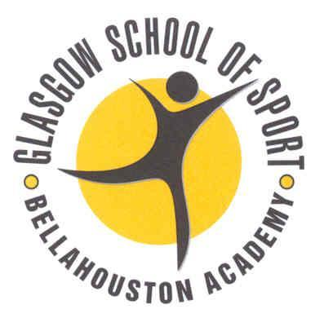
@ GIYBC

View our privacy statement on http://www.glasgowbadminton.btck.co.uk/About%20us/DataProtectionPolicy

Glasgow International Youth 2019

TEAM ENTRY – Under 13
Team Name
Country
Coach/Leader
Email
Telephone
Please return to iain.pringle@glasgowlife.org.uk

UNDER 13 BOYS
Name | Date of Birth | National Ranking |  |  | Individual Partnerships
 |  | BS | BD | XD | Doubles Partner | Mixed Partner

UNDER 13 GIRLS
Name | Date of Birth | National Ranking |  |  | Individual Partnerships
 |  | GS | GD | XD | Doubles Partner | Mixed Partner

Glasgow International Youth 2019

TEAM ENTRY – Under 15
Team Name
Country
Coach/Leader
Email
Telephone
Please return to iain.pringle@glasgowlife.org.uk

UNDER 15 BOYS
Name | Date of Birth | National Ranking |  |  | Individual Partnerships
 |  | BS | BD | XD | Doubles Partner | Mixed Partner

UNDER 15 GIRLS
Name | Date of Birth | National Ranking |  |  | Individual Partnerships
 |  | GS | GD | XD | Doubles Partner | Mixed Partner

Glasgow International Youth 2019

ACCOMMODATION
Team Name
Country
Coach/Leader
Email
Telephone
Please return to iain.pringle@glasgowlife.org.uk

HOTEL
Please list names of each person in same room
Room  Number | Person 1 | Person 2 | Person 3 | Single / Twin / Family Room
1
2
3
4
5
6
7
8
9
10

Glasgow GO Urban, 57 Paisley Road West, Glasgow G51 1RW (0141 419 1136)

Glasgow International Youth 2019

MEALS
Team Name
Country
Coach/Leader
Email
Telephone
Please return to iain.pringle@glasgowlife.org.uk

Dates | Menu | Total number of meals  @ £10 per person
Friday 17th May | Option 1  Beef Lasagne (contains Gluten, Egg, Milk, Soya & Celery)  Garlic Bread and Salad  Bread, Fruit, Fruit Juice / Water  Chocolate Fudge Cake
Option 2
Macaroni Cheese (Gluten, Egg, Milk, Mustard & Celery)
Garlic Bread, Salad, Fruit, Fruit Juice / Water
Chocolate Fudge Cake
Saturday  18th May | Option 1  Chicken Curry (contains Gluten, Egg, Milk & Celery)  Boiled Rice, Naan bread  Bread, Salad, Fruit, Fruit Juice / Water  Lemon Drizzle Cake with Raspberry Sauce
Option 2
Vegetable Curry (contains Gluten, Egg, Milk & Celery)
Boiled Rice, Naan bread
Bread, Salad, Fruit, Fruit Juice / Water
Lemon Drizzle Cake with Raspberry Sauce
Option 3
Meat Pasta Bake (contains Gluten, Egg & Milk)
Garlic Bread
Bread, Salad, Fruit, Fruit Juice / Water
Lemon Drizzle Cake with Raspberry Sauce
Please indicate any dietary requirements below:

Meals will be served at Glasgow GO Urban, 57 Paisley Road West, Glasgow G51 1RW (0141 419 1136)

