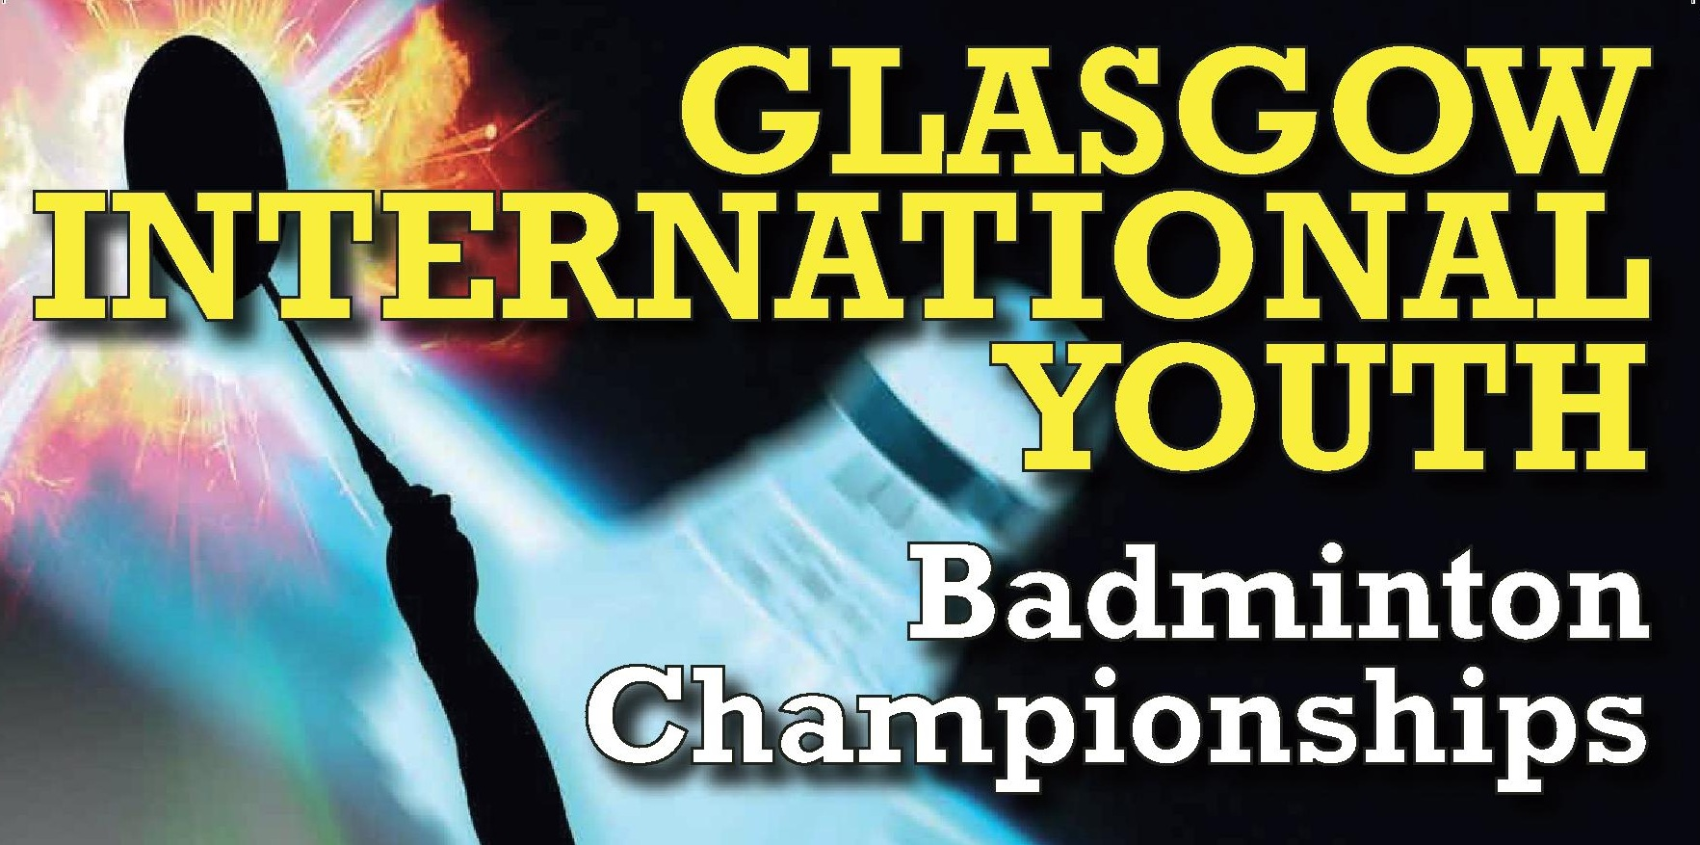
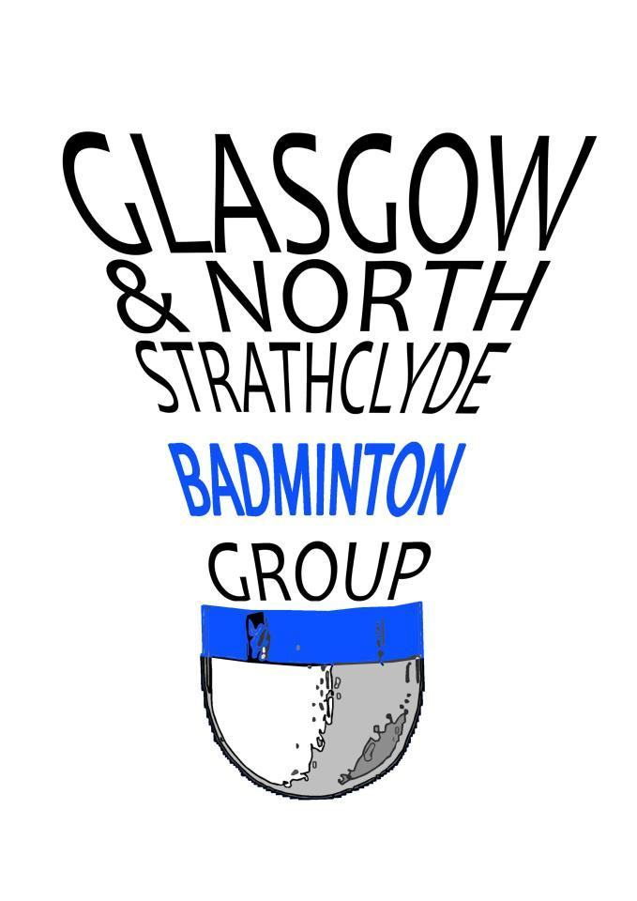

Glasgow International Youth 2019
Individual Entry Form

Dear Badminton Friends
Glasgow and North Strathclyde Group and Glasgow Sport would like to invite you to the seventh edition of the Glasgow International Youth Badminton Team and Individual Championships 2019. Last year we welcomed players from England, Germany, Hungary, Ireland, Portugal, Poland, USA, Wales and Scotland. Come and join us!

Organisers | Glasgow & North Strathclyde Group (Scotland)  Iain Pringle  Glasgow School of Sport  E: iain.pringle@glasgowlife.org.uk  Telephone: +44 141 287 5971 Mobile: +44 7766 456 936
Sanctioned by | BADMINTONscotland  The tournament will be played in full accordance with the laws of Badminton and Competition Regulations adopted by BADMINTONscotland as well as the regulations of the BWF
Age Groups | Under 13 (Born 2007 or later)  Under 15 (Born 2005 or later)
Eligibility | Scottish players must be affiliated to BADMINTONscotland  Non Scottish players must be affiliated through their National Associations to BWF.
Schedule | Saturday 18th May; Individual 0900 – 2100  Sunday 19th May; Semi-Finals/Finals 0900 – 1730
Closing Date | Entries must be received no later than 26th April 2019
Venues | National Badminton Academy (9 Courts), G14 9HD  Glasgow School of Sport (6 Courts), Glasgow, G41 5QE  Sir Craig Reedie Badminton Centre (6 Courts), Glasgow, G51 4TQ

Referee | Mrs Morag McCulloch
Draws |  | Draws will be available 7 days in advance of the competition
Entries |  | Online entry for Individual event:  https://www.tournamentsoftware.com/sport/tournament.aspx?id=BCCAAAED-BF8E-4A77-8DCF-48F327DE53D5  Sent to: Iain Pringle  Glasgow School of Sport  Bellahouston Academy, 30 Gower Terrace, Glasgow, G41 5QE  Email: iain.pringle@glasgowlife.org.uk
Individual |  | Players can participate in 3 categories. Singles and doubles will be played in pools. Mixed Doubles will be played using the cup system.
Entry Fee |  | Singles - £16 GBP per player  Level Doubles / Mixed Doubles £13 GBP per player
Finance  Payments GBP (£) |  | Glasgow and North Strathclyde Group  Bank: Bank of Scotland  Bank Account No: 00391761 Sort Code: 80-09-22  IBAN No.: BOFSGB21091  BIC/SWIFT: GB12 BOFS 8009 2200 3917 61  Team Entry – Invoice issued on receipt of entry  Individuals – Prepayment online or by post
Meals |  | Dinner will be available at £10 per person at the Glasgow GO Urban on Friday 17th and Saturday 18th May. Please request a meals booking from organisers.
T-Shirt |  | An official tournament T-shirt will be available and can be ordered in advance at a cost of £15. The shirt will be available to collect from organisers on the day of competition
Refund policy |  | The organisers will only consider refunds on an individual basis.
Insurance |  | The Organisers decline responsibility and covering of costs for possible injuries or other damages. It is up to participants to insure themselves.
Transport |  | Transport will only be provided if prior booking with organisers  Preferred Airport is Glasgow International  Public Transport is available to all venues
Hotel |  | The official hotel is Glasgow GO Urban  57 Paisley Road West, Glasgow G51 1RW (0141 419 1136)
Shuttlecocks |  | Yonex AS30 (included in the entry fee)
Café |  | Café facilities will be available through the hours of play at each venue.
Visa Requests |  | All players requiring a visa must apply in writing providing:  Name and designation  Passport number, place of issue, date of issue and expiry date
Insurance |  | The Organisers decline responsibility and covering of costs for possible injuries or other damages. It is up to participants to insure themselves

Medical | A physiotherapist will be present in the sports hall during the championships
Prizes | Individual – Gold, Silver and Bronze Medals
Clothing | BWF Regulations apply
Draws | The draw will be available to view on www.tournamentsoftware.com 7 days prior  to the start of the competition
Departures | Departures – Players departing from Glasgow are kindly requested to schedule flights after 6.00 pm on Sunday 19th May
Court Officials | Semi-finals and finals will be led by BADMINTONscotland Court Officials
Practice | Courts may be available for teams arriving Thursday. Where possible, practice courts will be made available at requested times, but this cannot be guaranteed.
Questions | Please email iain.pringle@glasgowlife.org.uk if you require further information
Website | http://glasgowbadminton.btck.co.uk/Competitions/GlasgowInternationalYouth

@ GIYBC

View our privacy statement on http://www.glasgowbadminton.btck.co.uk/About%20us/DataProtectionPolicy

Individual Competition - Conditions of play

- The tournament will be played in full accordance with the laws of Badminton and Competition Regulations adopted by BADMINTONscotland as well as the regulations of the BWF.
- A separate entry must be completed by each individual competitor.
- All matches will be played in accordance with the BWF Laws of Badminton. Details of these laws can be found on the BWF website www.bwfbadminton.org
- Players can receive coaching during matches.
- No pair shall be accepted for a Doubles event unless an entry has been received from both players. Players indicating “partner required” will be paired where possible.
- Players absent when called on to play may be scratched.
- The organisers reserve the right to refuse entry without giving their reason.
- Start times will be advised approximately 5 days prior to the championships.
- Late entries and entries sent without appropriate fees are unlikely to be accepted.
- Players must hold themselves ready to play not later than 9.00 am on competition days. Preliminary rounds up to and including quarter finals will take place on Saturday 17th May, with remaining semi-finals and finals taking place on Sunday 18th May.
- The organisers reserve the right to amend the schedule if required.
- Players should be in attendance 20 minutes before the time of their first match and may be called to play 20 minutes prior to the match time shown on the programme.
- Regarding unannounced withdrawals from tournaments, BADMINTONscotland will be informed and may consider a warning letter on the first offence and on a subsequent offence the matter may be referred to the Disciplinary Committee.
- Players must advise the Referee on arrival at the Championships if they do not wish to be included in photographs/Videos which may be taken over the course of the championships.
- Depending on number of entries, players may have to play qualification matches on Friday evening. Scottish rankings will be used as of closing date.

Glasgow International Youth Championships 2019
U13 (Born 2007 or later) |  |  | U15 (Born 2005 or later)
Name

Date of Birth |  |  |  |  | Postcode
Address
Telephone |  |  |  |  |  | Email
Club Name

BADMINTONscotland ID

Event |  | U13 / U15 |  | Name |  |  |  |  |  | GBP£
Boys Singles |  | £16
Girls Singles |  | £16
Boys Doubles Partner |  | £13
Girls Doubles Partner |  | £13
Mixed Doubles Partner |  | £13
T-Shirt |  | £15 |  | XS/S/M/L/XL Size ________
 |  |  |  | Total Fee Enclosed |  |  |  |  |  | £
Cheques Payable to: Glasgow and North Strathclyde Badminton Group
- Please accept the entries for the events against which I have placed my name
- I confirm that I have not taken part in any unauthorised Tournament, League or Match
- I am a member of __________________club affiliated to _________________Union/Association or
- I have an individual affiliation to BADMINTONscotland
- I understand I may have to play qualification matches on Friday 17th May from 1700 hrs
Players Signature

Glasgow International Youth 2019

MEALS
Team Name
Country
Coach/Leader
Email
Telephone
Please return to iain.pringle@glasgowlife.org.uk

Dates | Menu | Total number of meals  @ £10 per person
Friday 17th May | Option 1  Beef Lasagne (contains Gluten, Egg, Milk, Soya & Celery)  Garlic Bread and Salad  Bread, Fruit, Fruit Juice / Water  Chocolate Fudge Cake
Option 2
Macaroni Cheese (Gluten, Egg, Milk, Mustard & Celery)
Garlic Bread, Salad, Fruit, Fruit Juice / Water
Chocolate Fudge Cake
Saturday  18th May | Option 1  Chicken Curry (contains Gluten, Egg, Milk & Celery)  Boiled Rice, Naan bread  Bread, Salad, Fruit, Fruit Juice / Water  Lemon Drizzle Cake with Raspberry Sauce
Option 2
Vegetable Curry (contains Gluten, Egg, Milk & Celery)
Boiled Rice, Naan bread
Bread, Salad, Fruit, Fruit Juice / Water
Lemon Drizzle Cake with Raspberry Sauce
Option 3
Meat Pasta Bake (contains Gluten, Egg & Milk)
Garlic Bread
Bread, Salad, Fruit, Fruit Juice / Water
Lemon Drizzle Cake with Raspberry Sauce
Please indicate any dietary requirements below:

Meals will be served at Glasgow GO Urban, 57 Paisley Road West, Glasgow G51 1RW (0141 419 1136)

